**R PROGRAMMING**

Ques 1 : Write the R commands to do the following:

a.Create a numeric, character, integer and logical vector.

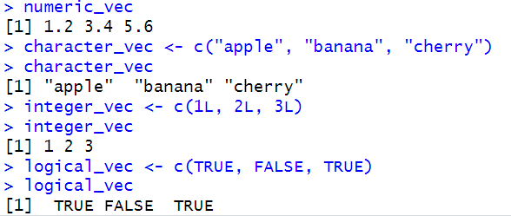

b. Create two numeric vectors x and y of different lengths. Next, observe the output of 2*x + y - 3.

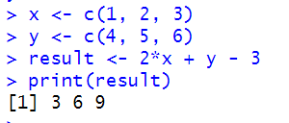

c. Create a sequence of all the odd numbers between 100 and 500.

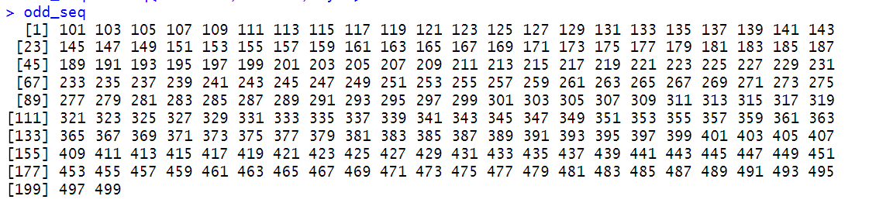

d. Calculate the mean and standard deviation of sequence created in part c.



e. Create a list containing a vector, an array and a list.

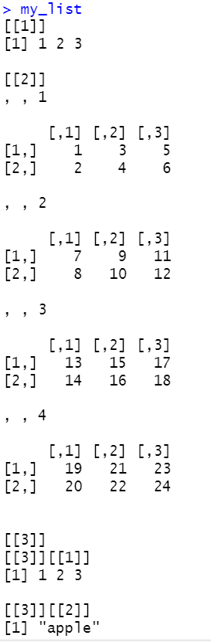

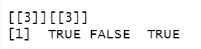

f. Create two multiplication compatible matrices M1 and M2 and display their product.

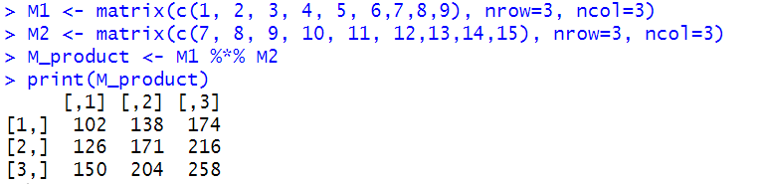

g. Display row-wise and column-wise mean of the matrix M1.

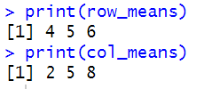

h. Combine the matrices M1 and M2 (as in previous part) using rbind/cbind function.

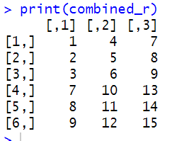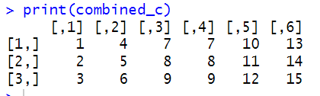

i.Convert a 3x4 matrix into 2x4 matrix.

